George Fraher

2/27/24

DBMS - Database management System - software that interacts with the end users ex. MySQL, PostgreSQL

What is a database? A shared collection of logically related data and its description

Databases have two models: Relational and Non-Relational

* Relational - These model data as rows and columns in a series of tables
* Non-Relational - Collectively referred to as NoSQL, They use different query languages

What is the general architecture of a database? 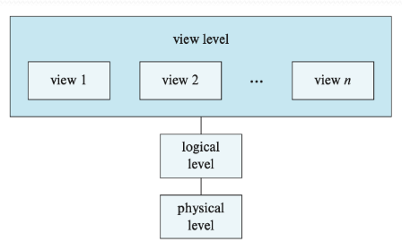

* Logical level: describe what data are stored in the database, and what

relationship exist among those data

* Physical level: describe how the data are actually stored

Two models of modern databases:

Data Model:

* A collection of tools for describing:
  + Data
  + Data relationships
  + Data semantics
  + Data constraints

Relational Model:

* Use a collection of tables to represent both the data and the relationships

among those data

What are the two types of database languages?

DML - Data-Manipulation Language

* Used to specify the schema of the database (define the organization in other words)

DDL - Data-Definition Language

* To Express data queries and updates

**Format of a Query**

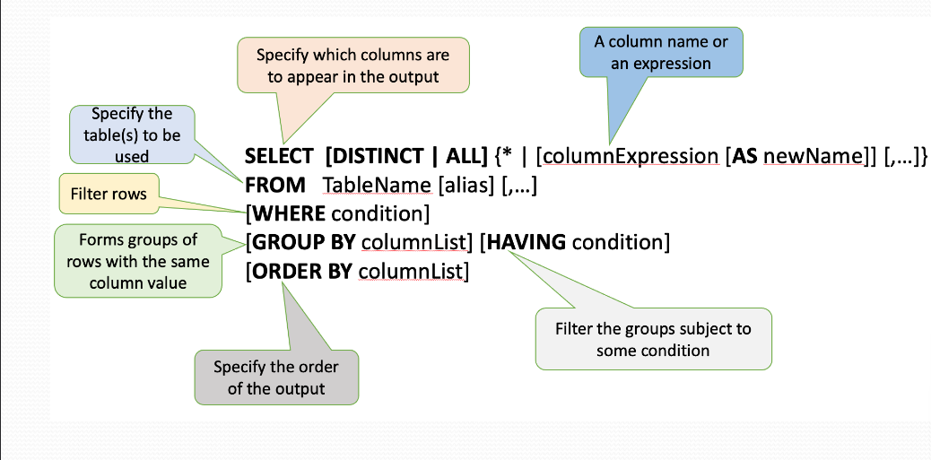

**What is the difference between a public key and a foreign key?**

Public Key:

* A primary key is a column or a set of columns in a database table that uniquely identifies each record in that table The primary key must have a unique value for each record and NULL values are not allowed

Foreign Key:

* A foreign key is a column or a set of columns in a database table that refers to the primary key in another table. It establishes a link between the two tables.

The Where clause has Five basic search conditions

* Comparison
* Range
* Set membership
* Pattern match
* Null

Order of Operations in a Query

1. FROM
2. WHERE
3. GROUP BY
4. HAVING
5. SELECT
6. ORDER BY

What is an Aggregrate Function?

An Aggregrate Function takes a collection (a single column of a table) of values as input and return a single value

* Can be only used in SELECT clause and HAVING clause, Commonly used keywords for Aggregrate functions are:
  + AVG (average)
  + SUM (total)
  + MIN (minimum)
  + MAX (maximum)
  + COUNT (count)

What is a subquery?

* a mechanism to embed a Select statement within another Select statement

The JOIN Operator:

* Combine information from two tables by forming pairs of related rows from the two tables
* Combine a selection and a Cartesian product into one single operation
  + Types of Joins:
    - OUTER JOIN
      * returns all rows from both tables, with NULL values for columns where there is no match
    - INNER JOIN
      * Returns only the rows where there is a match in both tables based on the specified condition
    - LEFT OUTER JOIN
      * Returns all rows from the left table and the matched rows from the right table
    - RIGHT OUTER JOIN
      * Returns all rows from the right table and the matched rows from the left table
    - FULL OUTER JOIN
      * Returns all rows when there is a match in either the left or right table

Set operations:

* UNION
  + used to combine the result sets of two or more SELECT statements. It returns a result set that contains all the unique rows from the combined queries
* INTERSECT
  + used to retrieve the common rows between two result sets. It returns only the rows that are present in both queries
* EXCEPT
  + used to retrieve the rows that are present in the first result set but not in the second result set

Modifying a Database:

* Deletion (DELETE)
  + used to remove one or more rows from a table based on a specified condition
* Insertion (INSERT INTO)
  + used to add new rows of data into a table. You can specify the values for each column or provide values for all columns
* Updates (UPDATE)
  + used to modify existing records in a table. You specify the columns to be updated and the new values, along with a condition to identify the rows to be updated
* CREATE TABLE
  + used to define a new table in a database. It specifies the table name, along with the names and data types of its columns
  + Integrity constraints
    - Primary Key Constraint: Ensures that each record in a table has a unique identifier.
    - Foreign Key Constraint: Defines a relationship between two tables, ensuring referential integrity.
    - Unique Constraint: Ensures that values in a column or a group of columns are unique.
    - Check Constraint: Enforces a condition on the values allowed in a column.
* DROP TABLE
  + used to remove an existing table and its data from the database
* ALTER TABLE
  + used to modify an existing table, such as adding or dropping columns, modifying data types, or adding constraints